Below is the script used to derive top 5 employees with highest rating(names ordered in alphabetic manner)-

**Pig –x local;**

**emp_details = LOAD '/home/acadgild/pig/employee_details.txt' USING PigStorage(',') AS (emp_id:int, name:chararray, salary:int, rating:int);**

**grpd = GROUP emp_details BY rating;**

**top5 = FOREACH grpd {**

**sorted = ORDER emp_details by name ASC;**

**top1 = limit sorted 1;**

**generate FLATTEN(top1);**

**};**

**grpd2 = FOREACH top5 GENERATE emp_id, name;**

**dump grpd2;**

Each and every relation has been explained below with its immediate corresponding output-

Start pig in local mode-

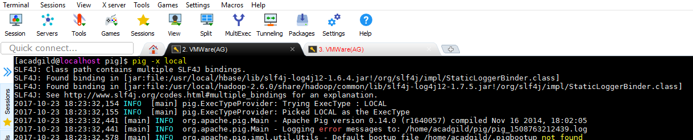

Load the emp_details.txt file using PigStorage

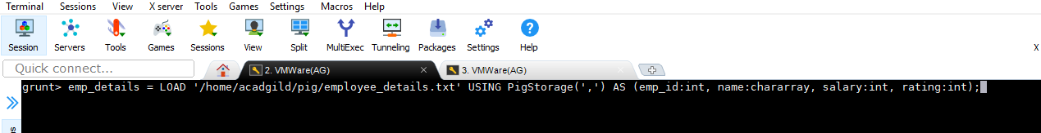

Contents of file-

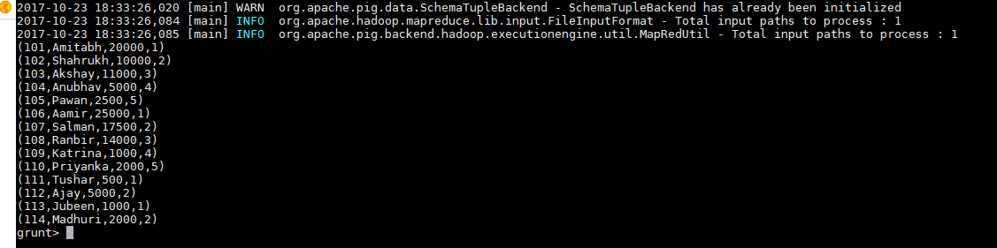

Group the data by rating-

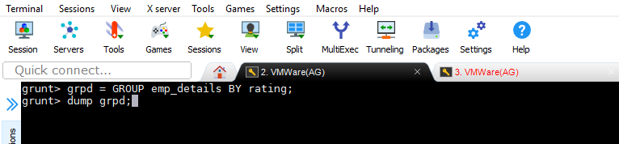

Result of GROUP-

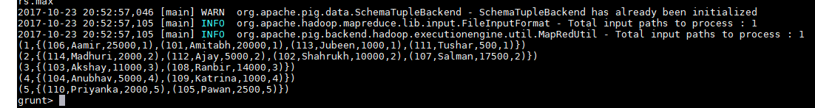

Below script takes out the tuple from the bag arranged with name in alphabetic order-

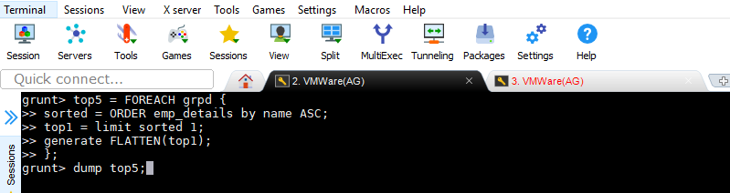

Dump results-

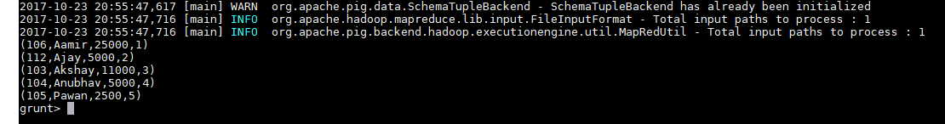

Extract emp_id and name as per question-

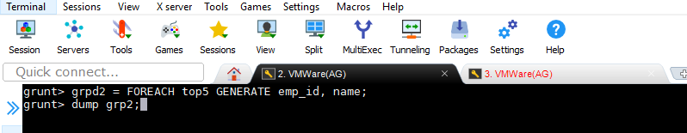

**Final O/P-**

